**Human Resource Information System for Department of Interior and Local Government of the Cordillera Administrative Region (DILG-CAR)**

An IT Project Proposal

Presented to the

Faculty of the School of Computing and Information Sciences

Saint Louis University

In Partial Fulfillment

of the Requirements for the Course

IT 411

by

Arvince Neil A. Alcaide

Sarah Mae E. Centino

Denver D. Culbengan

Ryan Christian A. De Guzman

Danielle Phillip A. Estrellado

Aerhielle Cassandra E. Leonen

Paul Christian C. Sam

Benedict M. Suarez

Laurence F. Balmeo

Project Adviser

December 2017

**Abstract**

Offices in general has difficulties in monitoring, tracking and updating different files and documents mostly offices that still utilize manual processes hence requires effective information management. Information Management guarantees information can be accessed easily and let the users manipulate, track and monitor files and documents fluently. Since the Human Resource and Records Section (HRRS) under the Finance & Administrative Division (FAD) of the Department of Interior and Local Government Cordillera Administrative Region (DILG-CAR) face these difficulties in keeping manual records and managing paper-based records, the developers will create a web application that helps the management and monitoring of files and documents of the said government section.

The developers will utilize the methodology Evolutionary-exploratory Model which ensures the understanding of the requirements, the steady progress of the proposed system and the constant feedback of the client which helps the developers to produce the desired product.

The Human Resource Information System (HRIS) that will be developed for the HRRS will assist the employees in managing and tracking specifically the Personal Data Sheet (PDS), Leaves, Service Record, Notice of Step Increment (NOSI), Notice of Salary Adjustment (NOSA) and updating of Plantilla. Also, some manual processes will be computerized to maximize the effectiveness of the system.

**Table of Contents**

**ABSTRACT …………………………………………………………………………… ii**

**LIST OF FIGURES ………………………………………………………………….. v**

**LIST OF TABLES …………………………………………………………………… vii**

**CHAPTER 1: INTRODUCTION**

1.1 Context of the Study ……………………………………………………… 1

1.2 Background of the Study ………………………………………………… 1

1.3 Statement of the Problem ………………………………………………… 9

1.4 Statement of the Objectives ……………………………………………… 14

1.5 Scope of the Project ……………………………………………………… 14

1.6 Significance of the Study ………………………………………………… 14

1.6.1 To the Employee ………………………………………………. 14

1.6.2 To the HRRS ……………………….………………………….. 14

1.6.3 To the DILG-CAR …………………………………………….. 14

**CHAPTER 2: METHODOLOGY**

2.1 Requirement Gathering ………………………………………………….. 15

2.1.1 Data Gathering ………………………………………………… 15

2.2 Quick Design …………………………………………………………….. 16

2.2.1 Design Tools …………………………………………………… 16

2.2.1.1 Entity-Relationship Diagram ………………………… 16

2.2.1.2 Relationship Database Schema ………………………. 16

2.2.1.3 System Architecture ………………………………….. 16

2.2.1.4 Site Map ………………………………………………. 16

2.3 Building Prototype ……………………………………………………….. 17

2.4 Customer Evaluation …………………………………………………….. 17

2.5 Refactoring Prototype ……………………………………………………. 17

2.6 Final Product ……………………………………………………………... 17

2.7 Timeline of the System …………………………………………………... 18

**CHAPTER 3: OUTCOMES AND RESULTS**

3.1 Requirements Specification …………………………………………….. 19

3.1.1 Functional Requirements ……………………………………… 19

3.1.2 Non-Functional Requirements ………………………………… 20

3.2 System Architecture …………………………..………………………… 21

3.3 Site Map ………….……………………………………………………… 23

3.4 Data Architecture

3.4.1 Entity-Relationship Diagram …………………………………. 25

3.4.2 Data Schema ………………………………………………….. 27

3.5 Prototypes

3.5.1 Human Resource ……………………………………………… 31

3.5.2 Employee ……………………………………………………… 45

3.5.3 Super User ……………………………………………………... 50

**REFERENCES** …………………………………………………………….. 57

**APPENDICES**

Appendix A. Daily Time Record …………………………………… 58

Appendix B. Type of Leaves ……………………………………….. 59

Appendix C. Application for Leave Form ………………………….. 61

Appendix D. Computation of Leaves Credit ………………………. 62

Appendix E. Service Record ………………………………………… 64

Appendix F. Notice of Step Increment ……………………………... 65

Appendix G. Notice of Salary Adjustment …………………………… 66

Appendix H. Leave Ledger Card ……………………………………… 67

Appendix I. Personal Services Itemization and Plantilla of Personnel.. 68

Appendix J. Personal Data Sheet …………………………………… 69

**List of Figures**

Figure 1. HRRS Organizational Chart …………………………………………………. 2

Figure 2. Processing of Personal Data Sheet …………………………………………… 3

Figure 3. Processing of Employee’s Leave Application ……………………………….. 4

Figure 4. Processing of Employee’s Leave Credits …………………………………….. 5

Figure 5. Updating of Plantilla ………...………………………………………………… 6

Figure 6. Processing of Employee’s Service Record …………………..…..…………… 7

Figure 7. Processing of Employee’s NOSI …………………………….……………….. 8

Figure 8. Processing of Employee’s NOSA …………………………….……………….. 8

Figure 9. Personal Data Sheet System …………………………………………………… 9

Figure 10. Leave Application System …………………………………………………… 10

Figure 11. Leave Ledger System ………………………………………………………… 11

Figure 12. Plantilla System ……………………………………………………………… 11

Figure 13. Service Record System ………………………………………………………. 12

Figure 14. NOSI System ………………………………………………………………… 12

Figure 15. NOSA System ……………………………………………………………….. 13

Figure 16. Evolutionary-Exploratory Model …………….……………………………….. 15

Figure 17. Timeline of the System ……………………………………………………….. 18

Figure 18. System Architecture ………………………………………………………… 21

Figure 19. HR Admin Officer Module Site Map ……………………………………… 23

Figure 20. Employee Module Site Map ………………………………………………… 23

Figure 21. Regional Director Module Site Map ………………………………………. 24

Figure 22. Entity – Relationship Diagram …………………………………………….. 25

Figure 23. Entity – Relationship Diagram …………………………………………….. 26

Figure 24. HR Log In …………………………………………………………………. 31

Figure 25. HR Dashboard …………………………………………………………….. 31

Figure 26. HR Sign up ………………………………………………………………… 32

Figure 27. HR Employee’s Account ………………………………………………….. 32

Figure 28. HR Employee’s Account New Password …………………………………. 33

Figure 29. HR Employee’s Updated Personal Data Sheet*…………………….*………… 33

Figure 30. HR Personal Data Sheet of Employee…………………………………….. 34

Figure 31. HR Pending Employee ……………………………………………………. 34

Figure 32. HR Pending Employee ………….………………………………………… 35

Figure 33. HR Employee …………………………………………….………………… 35

Figure 34. HR Employee Profile ……………………………………………………… 36

Figure 35. HR Activate and Deactivate Employee Account …………………………… 36

Figure 36. HR Generate Report …………….………………………………………….. 37

Figure 37. HR Edit Report …………………………………………………………….. 37

Figure 38. HR Edit Report ……………………………………………………………. 38

Figure 39. HR Edit Leave Ledger ……………………………………………………. 38

Figure 40. HR Reports…..………………………………………………………….…. 39

Figure 41. HR Reports Service Record ……………………………………………….. 39

Figure 42. HR Reports Service Record ………………………………………………… 40

Figure 43. HR Pending Leave …………………………………………………………. 40

Figure 44. HR Application for Leave …………………………………………………. 41

Figure 45. HR Plantilla …………….…………………………………………………. 41

Figure 46. HR Salary Grade ….………………………………………………………. 42

Figure 47. HR Previous Salary Grade …..…………………………………………..... 42

Figure 48. HR Add Salary Grade ……………………………………………………… 43

Figure 49. HR Plantilla Division ………………..…………………………………….. 43

Figure 50. HR Plantilla Edit ………………………………………………………….. 44

Figure 51. HR Plantilla Promotion and Demotion …………………………………… 44

Figure 52. Employee Reset User Password…………………………………………….. 45

Figure 53. Employee New Password ………………………………………………….. 45

Figure 54. Employee Dashboard ………………………………………………………. 46

Figure 55. Employee Profile …………………………………………………………… 46

Figure 56. Employee Personal Data Sheet …………………………………………….. 47

Figure 57. Employee Edit Personal Data Sheet ……………………………………….. 47

Figure 58. Employee Application Leave Form ………………………………………… 48

Figure 59. Employee Leave Summary …………………………………………………. 48

Figure 60. Employee Service Record …………………………………………………… 49

Figure 61. Employee Notification ……………………………………………………… 49

Figure 62. Super User Dashboard ………………………………………………………. 50

Figure 63. Super User Dashboard What’s New ……………………………………….. 50

Figure 64. Super User Employees ……………………………………………………… 51

Figure 65. Super User View Employee Details ………………………………………… 51

Figure 66. Super User Dropdown Option ………………………………………………. 52

Figure 67. Super User Select Dropdown Name ………………………………………… 52

Figure 68. Super User Inactive Employees …………………………………………….. 53

Figure 69. Super User Inactive Employee Details …………………………………….. 53

Figure 70. Super User Personal Data Sheet of Employees ……………….……………. 54

Figure 71. Super User Service Record of Employee …………………………………… 54

Figure 72. Super User Plantilla ………………………………………………………….. 55

Figure 73. Super User New Plantilla Setup ……………………………………………. 55

Figure 74. Super User Leave Reports ………………………………………………….. 56

Figure 75. Super User View Leave Details …….………………………………………. 56

**List of Tables**

Table 1: Functional Reguirements ……………………………………………………… 19

**Chapter 1: Introduction**

* 1. **Context of the Study**

Human Resource Information System (HRIS) is a system used to acquire, store, manipulate, analyze, retrieve and distribute information regarding a section like Human Resources by providing ease in compiling and finding certain documents in future need within the organization (Michael J. Kavanagh and Richard D. Johnson, 2018).

The proposed system focuses on Human Resource and Records Section (HRRS) of the Department of Interior and Local Government of Cordillera Administrative Region (DILG-CAR). HRRS is a section that handles the informational documents of the office which represents the memory of an organization providing tangible evidences of an organization activities and transactions, employee benefits, redeployment, termination, job description, information of employees and the likes.

DILG-CAR assists and advise the president promulgation of policies, regulation, programs, and projects to promote peace and order, close general supervision for local governments, promotion of autonomy and community empowerment with a consistent monitor of compliance thereof (DILG, 2013).  Furthermore, DILG-CAR functions in organizing and training primarily for the performance of police functions, a police force that is national in scope and civilian in character. With the use of the information maintains and handheld by the HRRS it strengthens the decision making of DILG-CAR, it will support on how DILG-CAR will act concerning the matter. Elective Local Officials Profile Database System (ELOPDS) has a database where the DILG Field Officers encode the personal data sheets of the governors, vice governors, mayors, vice mayors, and councilors of different provinces, municipality, and cities in all over the Philippines.

* 1. **Background of the Study**

Under the Finance and Administrative Division (FAD) of DILG-CAR is the Human Resource and Records Section (HRRS) which handles the informational documents that are used in the organization, the regional office has 32 employees and a majority of employees uses 35 personal desktop computers with an operating system of Windows 10, 64-bit. All computers are connected to 400mbps – 750mbps internet from Department of Information and Communications Technology (DICT) fiber and more than 15mbps internet from PLDTbiz. This informational document contains information about employees, wages and salary, training and development, promotion, termination and many other information about personnel records. The HRRS specifically handles the Personal Data Sheet (PDS), Daily Time Record (DTR), Service Records, Notice of Step Increment (NOSI), Notice of Salary Adjustment (NOSA), Leave Ledger Card, Application for Leave of the employee and the Personal Services Itemization and Plantilla of Personnel (PSIPOP) or Plantilla of the DILG-CAR.

Most of the documents are still being handled manually and are still paper-based, the HRRS is also using productivity tools like Microsoft Word and Microsoft Excel to manually compute data, digitally store the information regarding about the documents, and generate, edit and update reports. Every employee has a Microsoft Word and Excel file that are named after them, the files are reports about that specific employee. Regardless with the manual processes in the regional office, ELOPDS is one of the automation process the office has.

|  |
| --- |
| **FINANCE and ADMINISTRATIVE DIVISION (FAD)** |
| Chief Administrative Officer |
| Supervising Administrative Officer |

|  |
| --- |
| **HUMAN RESOURCE and RECORD SECTION (HRRS)** |
| Administrative Officer V (HRMO)  (HR Admin Officer) |
| Administrative Officer IV |
| Administrative Officer IV |
| Administrative Aide IV |
| Administrative Aide IV |

*Figure 1: HRRS Organizational Chart*

The figure above *(see Figure 1)* shows the structure of the HRRS in DILG-CAR and the relations and relative ranks of their positions.

The following are the current process of HRRS in DILG-CAR:

1. Processing of Personal Data Sheet (PDS) – The PDS form (*see appendix J)* has (4) pages, these pages contain information of the employee’s personal information, family background, educational background, civil service eligibility, work experience, voluntary work, training program, and other information as entitled in the PDS form. Each employee must submit their PDS annually whether there is a change or not, then the collected PDS will be part of the 201-Report that will be submitted to the Central Office by the HR Admin Officer *(see Figure 2 below)*. 201-Report is referred to all information of the employees (e.g., appointments, contracts, actions, orders and other information). As a result, the HRRS receives a large number of documents that must be checked individually and a large number of paper-based documents that must be check individually and manually.

File/Update

PDS



**DILG-CAR Employee**

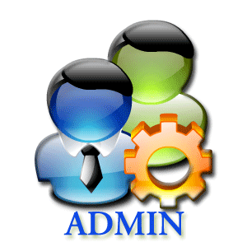

**DILG-CAR HR Admin Officer**



**Filing Cabinet**

Submit to HR

Return for correction/s



PDS

Store Validated PDS

*Figure 2*

1. Processing of Employee’s Leaves Application – These are the leaves *(see appendix B)* that an employee of DILG-CAR can avail; Paternity Leave, Rehabilitation Leave, Terminal Leave, Special Emergency Leave, Force Leave, Sick Leave, Vacation Leave, Maternity Leave, Magna Carta for Women, Study Leave, Special Privilege Leave, Solo Parent Leave, Monetize Leave and Violence Against Women and Children Leave. (see Figure 3 below).

Approved Application



**Application for Leave**

Leave App



**DILG-CAR Employee**



**DILG-CAR HR Admin Officer**



**Filing Cabinet**

Submit to HR

Disapproved Application

Submit to Officer in Charge



**DILG-CAR Department Officer**



**DILG-CAR Regional Director**

Submit to RD

Store Approved App Leave

Disapproved Application

Disapproved Application

*Figure 3*

1. Processing of Employee’s Leave Credits - leave points *(see appendix D)* are given to employee’s every first working day of the month, leave points will be consumed when an employee files an application for leave and renders the given leave, the remaining points will be computed as leave credits. Remaining leave credits of the last month will be added to the leave credits of the next month and so on and so forth. When the leave credits are not consumed it will accumulate and will be converted into cash when an employee files a resignation. An employee can borrow leave points from vacation leave credit to sick leave credits but not vice versa. When an employee consumed all the leave credits and still files a leave and renders it, the salary of the employee will be deducted base from the number of days of the leave. The HR Admin Officer manually store and computes the leave credits of each employee in a spreadsheet file entitled Leave Ledger Card *(see appendix H)*, some data needed for the computation are in the DTR and Leave Form *(see Figure 4 below)*.

**Last Working day of the Month**

**First Working day of the Month**



Store Leave Ledger

Giving of leave points



**DILG-CAR HR Admin Officer**



**Filing Cabinet**



**Leave Ledger**

Consumed leave points



Acquire Leave Points and Consumed Leave Points, and retrieve the updated Leave Ledger

Computation of Leave Credits

*Figure 4*

1. Updating of Plantilla - The Plantilla *(see Appendix I)* is being released by the Department of Budget and Management (DBM) every start of the year and will be use by the HR Admin Officer all throughout the year. Afterwards the HR Admin Officer will send an updated version of the Plantilla to the DBM through the Government Manpower Information System (GMIS) official website every end of the year for documenting purposes. The Plantilla is a form that monitors the employee’s status in the DILG-CAR, it holds the entire population of DILG-CAR. Every time an employee is either promoted or re-assigned, the Plantilla will be the first to be updated. If there are changes within Plantilla, it will reflect on the reports connected in the Plantilla such as the PDS and Service Record *(see Figure 5 below)*. Changes made in the Plantilla are done manually using a spreadsheet. The HR Admin Officer often uses the cut and paste method to obtain the information of a certain employee in the Plantilla, this is done to transfer the employee’s information to the designated vacant position in the Plantilla. By using spreadsheet to do the process of promoting and re-assigning makes the work longer and arduous because in every Division of the Plantilla has its own different spreadsheet file. When an update occurs the HR Admin also needs to manually update the forms related to the Plantilla.

**PDS**

Update both PDS and Service Record

Updated Plantilla

Sent to DILG-CAR HRRS



**Plantilla**

Changes, updates in Plantilla



**Filing Cabinet**

Store Plantilla

**DBM**



**DILG-CAR HR Admin**



**Plantilla**



**Service Record**



**New Plantilla**

*Figure 5*

1. Processing of Employee’s Service Record, NOSI and NOSA– Service Record *(see appendix E)* serves as the summary of the whole working experience of a government employee in the DILG-CAR. Each employee’s service record is stored in a word document file named after them, a hard copy of the report can be requested from the DILG-CAR HR Admin Officer. Data from the Service Record are acquired from the Plantilla, which means that if the employee is promoted or reassigned in the Plantilla the Service Record of that employee will be updated as well, also the release of NOSA *(see appendix G)* or NOSI *(see appendix F)* will affect the Service Record. In this case, updating of Service Record will be arduous and will take longer because if either the NOSA or NOSI or Plantilla will be updated the HR Admin Officer will check the updated files and manually update the service record of each employee. NOSA is Notice of Salary Adjustment which is being released every first working day of the year when the National Budget Circular of the DBM order for salary adjustment *(see figure 8)* and NOSI is Notice of Step Increment will be released when an employee is qualified for a promotion or an employee completed a three (3) years of working service on the same position *(see figure 7)*. Salary Grade is a table that contains the different levels of salary an employee can have, starting from salary grade 1 to salary grade 28 *(see Figure 6).*

Request for Service Record



**DILG-CAR Employee**



**DILG-CAR HR Admin**



**Filing Cabinet**



**Service Record**

Store Service Record

Retrieve Service Record

*Figure 6: Service Record*



**Service Record**



**DILG-CAR Employee**



**Plantilla**



**NOSI**

Release NOSI

Update Service Record

Update Plantilla

Inform Employee

**DILG-CAR HR Admin Officer**

*Figure 7: NOSI*



**Service Record**



**DILG-CAR Employee**



**NOSA**

Sent to DILG-CAR

HRRS

Update Service Record

Update Plantilla

Inform Employee



**Plantilla**



**DILG-CAR HR Admin**

Release NOSA



**Philippine Government**

*Figure 8: NOSA*

* 1. **Statement of the Problem**

1. Checking and Monitoring of Leave Applications of every employee is arduous.

2. The employees who attended seminars and trainings are difficult to monitor due to their outdated PDS.

3. The employees who leave on the different days and currently on their leaves are difficult to monitor.

4. The HRRS uses a Microsoft Excel to have the computation of every employee's leave credits.

5. The HRRS uses a Microsoft Excel to monitor the Plantilla and they use copy and paste method to have a history of their Plantilla.

6. In generating the employee's Service Record, NOSI and NOSA typographical error is a common error that HRRS is encountering.

The system will be a web application that employees and the HRRS can be access from the office. The system will have a login system to secure the information of the employee and the HRRS. The new user will have to input the first part of the PDS which is the personal information section. The main processes of our system are to view, edit, and generate the following:

1. PDS – in the system, the process of the PDS is almost similar to the current process of DILG-CAR except in the system, the process is computerized and does not have to be print. The PDS in the system can be view and edit by the employee anytime there is an update in their PDS and can be print if needed. The DILG-CAR HR Admin can now easily check the update of their PDS.

View Employee PDS

Generated PDF file of PDS



**DILG-CAR Employee**

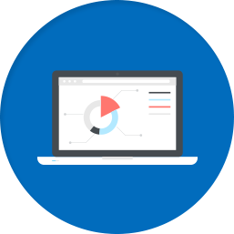

**DILG-CAR HRIS Web Application**



**DILG-CAR HR Admin Officer**

Log in  
Filling out of PDS

View/Update/Edit PDS for Corrections

Validation of Employee PDS

Submit to HR

Store PDS

Retrieve PDS



**Database**



**DILG-CAR Regional Director**

*Figure 9: Personal Data Sheet System*

1. Leave Application – there will be a template for the application which an employee can fill up and print afterwards then submit the printed file to the DILG-CAR HR Admin Officer. After the DILG-CAR HR Admin Officer checked the form, it will be delivered to the employee’s Department Officer then to the Regional Director to be approved. If approved by both then it will be marked by the DILG-CAR HR Admin Officer in the system. This will help the DILG-CAR HR Admin Officer to monitor the leave of their employee. If an application for leave is declined, the application will be deleted after 2 working weeks.

Log in,  
Filling out of Leave Application,

View and edit Leave Application



**DILG-CAR Employee**

**DILG-CAR HRIS Web Application**



**DILG-CAR HR Admin Officer**

Marks “Accepted Leave” if the Regional Director Approves the Leave Application



**Database**

Store Leave Application

Retrieve Leave Application

Generated PDF file of Leave Application

Submit the printed Leave Application to HR

*Figure 10: Leave Application System*

1. Leave Ledger – the system can query some information of the employee to create their leave ledger.



**DILG-CAR Employee**



**DILG-CAR HR Admin Officer**

View Leave Ledger



**DILG-CAR HRIS Web Application**

View/Add/Update Leave Ledger



**Database**

Store Leave Ledger

Retrieve Leave Ledger

View Leave Ledger



**DILG-CAR Regional Director**

*Figure 11: Leave Ledger System*

1. Plantilla – the Plantilla can be edit, view, and generate by the HR admin Officer. The Plantilla in the system will have a function of promoting and re-assigning a certain employee and can archive employee too.

**Plantilla**



**DBM**



**DILG-CAR HR Admin Officer**



**DILG-CAR HRIS Web Application**



**Database**

Updated Plantilla

Sent to DILG-CAR HRRS

Store Plantilla

Retrieve Plantilla

Changes/ updates in Plantiila and automatically update both PDS and Service Record.

Sends New Plantilla

Retrieve Plantilla

*Figure 12: Plantilla System*

1. Service Record – some of the data will be query from the service experience in the PDS and the update will come from the Plantilla.



**DILG-CAR Employee**

Request for Service Record



**DILG-CAR HR Admin Officer**



**DILG-CAR HRIS Web Application**



**Database**

Store Service Record

Retrieve Service Record

Give Service Record

Store Service Record

Retrieve Service Record

*Figure 13: Service Record System*

1. NOSI and NOSA – there will be templates for NOSI and NOSA in the system and certain data’s can be query to supply some information



**DILG-CAR HR Admin Officer**



**DILG-CAR HRIS Web Application**

Release NOSI  
Updates Service Record and Plantilla



**DILG-CAR Employee**



**Database**

Notify Employee of NOSI

Newly updated Service Record and Plantilla

Retrieve Information from Service Record and Plantilla

Retrieve Plantilla

*Figure 14: NOSI System*



**Philippine Government**



**DILG-CAR HR Admin Officer**



**NOSA**

Release NOSA

Sent to DILG-CAR

HRRS



**DILG-CAR HRIS Web Application**



**Database**

Retrieve Information from Service Record and Plantilla

Newly Updated Service Record and Plantilla



**DILG-CAR Employee**

Notify Employee of NOSA

Release NOSA

Fill out NOSA template

Update Service and Plantilla

*Figure 15: NOSA System*

* 1. **Statement of the Objectives**

The objective of the project is to develop the HRIS, to automate manual working related processes between Employee and the Human Resource Administrator, and improve monitoring and checking of processes by the HRRS.

* To collect and determine the functional and non-functional requirements by gathering data that is significant in the development of the HRIS System.
* To establish this different architecture and models in designing the system which are the System Architecture, Site Map, Entity Relationship Diagram and Data Schema.
* To create a prototype of the system.
* To implement the design by using different tools and technologies.
* To present the system functions and feature through performing beta testing with different users.
* To maintain and deploy the system.
  1. **Scope of the Project**

The proposal of this project is to improve the system of the HRRS in the DILG-CAR. The developers conducted a requirement elicitation and analysis of the current condition of the regional office of DILG-CAR to collect data needed for the functional requirements of the HRIS for DILG-CAR and the following processes are observed as follows; processing of Personal Data Sheet, processing of employee's work time, processing of employee's leaves, processing of employee's leave credits, maintaining of the Plantilla, processing of employee's Service Record, NOSI, and NOSA. The proposed system will not include the Daily Time Record of the employee.

* 1. **Significance of Study**

**1.6.1 To the Employee**

It would make the work of employees easier and more convenient. The employees can view their PDS, Leaves, Service Record, NOSI, NOSA and Plantilla. Also, they can edit the PDS and file a leave via the system.

**1.6.2 To the HRRS**

It would help the HR Admin Officer to facilitate and monitor changes or updates regarding information in the system. Tracking, organizing, sorting data and generating reports will be faster and easier.

**1.6.3 To the DILG-CAR**

It would help the DILG-CAR to have faster operations in HRRS and make significant change in the processes involving in the particular section.

**CHAPTER 2**

**Methodology**

The methodology that the developers will use for the development of the system is the Evolutionary-Exploratory Model. With requirements that are constantly changing throughout the development of the system using the model is suitable for the project. By using this model, the developers will be able to understand much better the process and purpose of each part in different forms of the HRRS to make development more effective. Through analyzing the gathered data, frequent interviews with the HRRS and observing the current process the developers narrow down the essential requirements, and create features and modules. The developers design a diagram to explain the phases for the development of the system.



*Figure 16*

With the phases of the model (see Figure 16), the developers are improving and making changes with every iteration that is being made thus achieving the desired final product.

**2.1 Requirement Gathering**

The requirement gathering phase allows the developers to fully understand the demands and wants of the stakeholders, also can give a better grasp on what will the whole project can offer. Thus, making this phase critical to the development of the project. The developers must be thorough and concise on the information that will be gathered, the developers will gather information by interview, document analysis, observation and data gathering.

**2.1.1 Data Gathering**

The methods that the developers will use in gathering data are interviews, observation of the HRRS current processes, analyzation of different forms and documents.

The developers scheduled interviews with the Administrative Officer of the HRRS to fully understand their process and clarify information that is unclear, they asked the step by step process of different forms, problems and concerns occur in the office, explanation of different forms related to other forms, and how the system should process and the outcome of the forms generated by the system. The developers will also make an observation on the working area of the HRRS that will help the developers to have a good grasp on how the actual process work. Sample copies of reports and user records were also collected so that the developers may have a very good understanding about the content and the processes of the client’s work.

The developers will also base the interface of the system with the website ELOPDS which is suggested by RITCTU. ELOPDS has most of the functionalities to be used in the system, also RITCTU gave the theme to be followed.

**2.2 Quick Design**

In the quick design phase, the developers create design the back-end and the front-end of the system. This design is based on the requirements that will be gather in the requirement phase and the requirement or suggestion of the HRRS.

**2.2.1 Design Tools**

**2.2.1.1 Entity-Relationship Diagram**

The Entity-Relationship diagram will be used by the developers to represent the information system for DILG’s daily monitoring of work and to show the relationships between entities in the database.

**2.2.1.2 Relationship Database Schema**

This will support the ERD used by the developers, it will describe the data or information that is stored in the database. The schema represents the view of the entire database including its constraint to specify the rules for data in a table.

**2.2.1.3 System Architecture**

Application Architecture will be used in the development of the system to define the framework and structure of the organization’s application. It establishes the framework for agility, reliability, and scalability in the application system so that the application will respond effectively and efficiently to changes in the important information systems. And it defines the necessary application systems to process data and support solutions for the business requirements. It also shows how this application communicates with each other and to its users.

**2.2.1.4 Site Map**

Site Map will be used for the planning of the proposed web-based system and also to list the webpages of the proposed system.

**2.3 Building Prototype**

The prototype phase is the start of development of the quick design that is created by the developers. The developers will develop the prototype based on the current requirements and data gathered. The developers work both front-end and the back-end of the system.

**2.4 Customer Evaluation**

The client evaluation phase is where the client evaluates the system created by the developers. The people who will evaluate are from the HRRS or Regional Information & Communication Technology Unit (RITCTU) of the DILG-CAR. The software testing will be validation testing and the testing approach is black box. The client will give the developers feedback about the system. The evaluation will start by developers explain the progress of the system, then testing of data input in the system and see the output, finally recording the results of the evaluation. It will be repeat on Monday every week if both developers and client is available.

**2.5 Refactoring Prototype**

The refactoring prototype phase is where the developers refactors or update the system from the feedback of the client. After the client does the evaluation, if the client sees problems, a system error occurs or the client wants minor changes in the system or in some cases the developers found bugs then the developers will list it. Then the developers will fix the problems and the bugs then updated system to present it to the client. Then list all the update and added to new quick design and iterate the process.

**2.6 Final Product**

After all the building of prototype, evaluation, and refactoring to attain the system required, the final production phase will start. In this phase, the developers will present it to the whole employee of the DILG – CAR main office to demonstrates it to them so that they know how to use the system. The developers also make a manual of the system to help the employees and the HRRS how to use the system.

**2.7 Timeline of the system**



*Figure 17*

**Chapter 3: Outcomes and Results**

**3.1 Requirements Specification**

Table 1: The following are the list of functional requirements provided by the system.

|  |  |
| --- | --- |
| Employee | * Modify the personal information in the PDS * View the PDS * Update the PDS * Input the leave information * Modify the leave information * View the leave information * Update the leave information * View the Service Record |
| HR Admin Officer | * Generate the PDF file of PDS * Input data in the Leave Ledger * Modify leave ledger of employee * View the pending and approve leaves * View the Leave Ledger of employee * Update the Leave Ledger of employee * Accept or reject employee’s file leave * Print Leave Ledger * Input data in the Service Record * Modify the Service Record of employee * View the Service Record of employee * Update the Service Record of employee * Print Service Record * Input data in the Plantilla * Modify personal information in the Plantilla * View the Plantilla * Update the Plantilla * Select employee to promote, re-assign, or archive in the Plantilla * Print Plantilla * Modify the NOSI of employee * View the NOSI of employee * Update the NOSI of employee * Print the NOSI * Modify the NOSA of employee * View the NOSA of employee * Update the NOSA of employee * Print the NOSA * Search specific employee profile * Search, view and filter pending employees * Select a report to generate |
| Regional Director | * View the PDS of employee * View the Leave Ledger * View the Plantilla * View the Service Record * View pending and approved leaves |

**3.1.2 Non-Functional Requirements**

The following are the list of how the system should be:

* The system must be able to secure privacy of information
* The performance of the system should be fast; there should be no run-time constraints
* The system should provide accurate and precise data
* The system should be easy to operate and learn
* The system should be able to handle error detection and checking of duplicates
* The system should be able to handle capacity of resources and data to be processed

**3.2 System Architecture**

DILG-CAR Employee



Regional Director

DILG-CAR Employees

HR Admin Officer



HRIS for DILG-CAR



NETWORK

NETWORK

MySQL Database



*Figure 18: System Architecture for HRIS of DILG-CAR*

The system that will be develop can be access through a web browser, specifically Google Chrome and Mozilla Firefox. The developers decided the following technologies in developing the system namely HTML, JavaScript and CSS for the front end of the system while for the functionalities the developers have chosen the programming language called PHP together with its framework Laravel. To store the files needed by the system to work, the developers have chosen MySQL and phpMyAdmin in constructing the database of the HRIS of DILG-CAR.

To test the system and to make sure that the system is able to meet its requirement and the desired out is obtained, the following technologies for testing the system will be use are BlackBox and Selenium. These testing tools will test the logical paths of the system and checks if the input is properly accepted and the output is correct.

**3.3 Site Map**

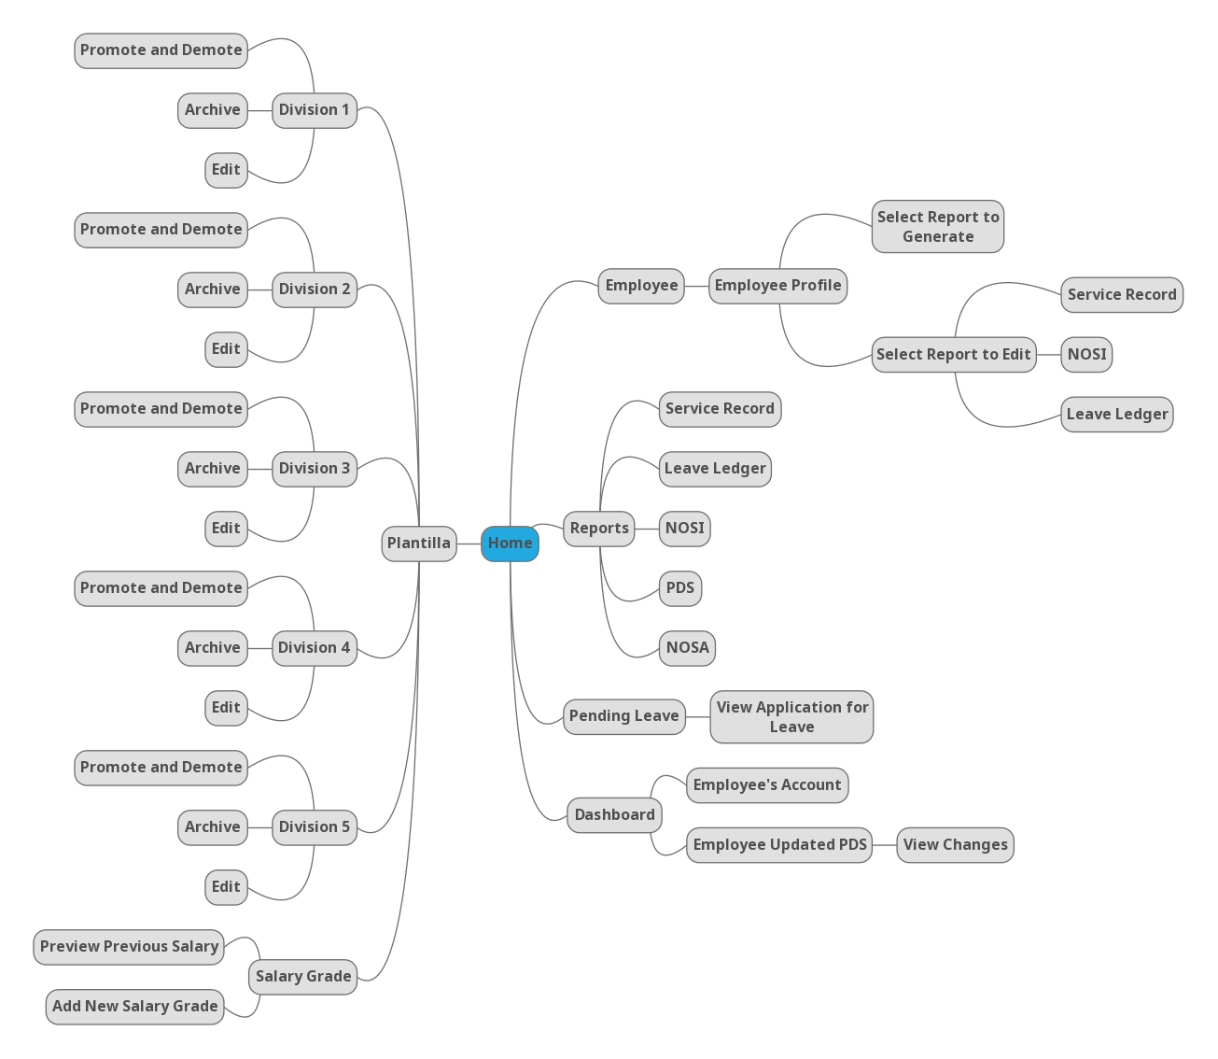

*Figure 19*: *HR Admin Officer Module Site Map*

The figure above *(see Figure 19)* shows the list of webpages that the HR Admin Officer can navigate through the web application.



*Figure 20: Employee Module Site Map*

The figure above *(see Figure 20)* shows the list of webpages that the employee can navigate through the web application.



*Figure 21: Regional Director Module Site Map*

The figure above *(see Figure 21)* shows the list of webpages that the Regional Director can navigate through the web application.

**3.4 Data Architecture**

**3.4.1 Entity-Relationship Diagram**



*Figure 22*



*Figure 23*

**3.4.2 Data Schema**

APPLICATION FOR LEAVE (app_id, emp_id, typeOfLeave, location, sickInfo, noOfWorkingDays, inclusiveDates, status)

FK emp_id References Employee Nulls Not Allowed

Delete Cascade, Update Cascade

CIVILSERVICE ELIGIBILITY (civilService_id, emp_id, civilServiceName, rating, dateOfExamination, placeOfExamination, licenseNumber, licenseDateOfValidity)

FK emp_id References Employee Nulls Not Allowed

Delete Cascade, Update Cascade

CHILDREN (family_id, fullname, dateOfBirth)

FK family_id References FamilyBackground Nulls Not Allowed

Delete Cascade, Update Cascade

DIVISION (division_id, division_code, division, province)

AK division_code

EDUCATIONAL BACKGROUND (educ_id, emp_id, level, nameOfSchool, basicEducationDegreeCourse, periodOfAttendanceFrom, periodOfAttendanceTo, highestLevelEarnedUnits, yearGraduated, scholarshipsAcademicHonorsReceived)

FK emp_id References Employee Nulls Not Allowed

Delete Cascade, Update Cascade

EMPLOYEE (emp_id, name, dateOfBirth, sex, civilStatus, height, weight, bloodtype, gsis, pagibig, sss, tin, citizenship, ressidentialAddressHouseBlockLotNo, residentialAddressStreet, residentialAddressSubdivisionVillage, residentialAddressBarangay, residentialAddressCityMunicipality, residentialAddressProvince, residentialAddressZipcode, permanentAddressHouseBlockLotNo, permanentAddressStreet, permanentAddressSubdivisionVillage, permanentAddressBarangay, permanentAddressCityMunicaplity, permanentAddressProvince, permanentAddressZipcode, telephoneNo, mobileNo, emailaddress, citizenship_country, citizen_info, password)

EMPVOLU (voluntaryWork_id, emp_id, position_title)

FK voluntaryWork_id References Voluntary Works Nulls Not Allowed

Delete Cascade, Update Cascade

FK emp_id References Employee Nulls Not Allowed

Delete Cascade, Update Cascade

EMPWORK (workExperience_id, emp_id, year)

FK workExperience_id References Work Experience Nulls Not Allowed

Delete Cascade, Update Cascade

FK emp_id References Employee Nulls Not Allowed

Delete Cascade, Update Cascade

FAMILY BACKGROUND (family_id, emp_id, spouseName, spouseOccupation, spouseEmployerBusiness, spouseBusinessAddress, spouseTelephoneNo, fatherName, motherName)

FK emp_id References Employee Nulls Not Allowed

Delete Cascade, Update Cascade

LEAVE LEDGER (ledger_id, emp_id, app_id, vacationAvailedLeaves, vacationNoOfAbsence, tardiness, vacationEarned, vacationBalance, vacationAbsenceWithPay, vacationAbscencesWithoutPay, sickAvailedLeaves, sickNoOfAbsenceTardiness, sickEarned, sickBalance, sickAbsenceWithPay, sickAbsencesWithoutPay, year)

FK emp_id References Employee Nulls Not Allowed

Delete Cascade, Update Cascade

FK app_id References ApplicationForLeave Nulls Not Allowed

Delete Cascade, Update Cascade

OTHER INFO (info_id, emp_id, skillsAndHobbies, nonAcademicDistinction, membership)

FK emp_id References Employee Nulls Not Allowed

Delete Cascade, Update Cascade

PLANTILLA (plantilla_id, emp_id, position_id, division_id, itemNumber, positionTitle, salaryGrade, authorized_sal, actual_sal, step_increment, area_code, area_type, level, ppaAttribution, civil)

FK emp_id References Employee Nulls Not Allowed

Delete Cascade, Update Cascade

FK position_id References Position Nulls Not Allowed

Delete Cascade, Update Cascade

FK division_id References Division Nulls Not Allowed

Delete Cascade, Update Cascade

PDS EMPLOYEE RESPONSE (PdsEmployeeResponse_id, emp_id, no34ResponseA, no34ResponseB, no34ResponseDetails, no35ResponseA, no35ResponseB, no35Details, no36Response, no36ResponseDetails, no37Response, no37Details, no38ResponseA, no38ResponseB, no38ResponseDetails, no39Response, no39ResponseDetails, no40ResponseA, no40ResponseADetails, no40ResponseB, no40ResponseBDetails, no40ResponseC, no40ResponseCDetails)

FK emp_id References Employee Nulls Not Allowed

Delete Cascade, Update Cascade

POSITION (position_id, emp_id, position)

FK emp_id References Employee Nulls Not Allowed

Delete Cascade, Update Cascade

REFERENCES (reference_id, emp_id, name, address, telephoneNo)

FK emp_id References Employee Nulls Not Allowed

Delete Cascade, Update Cascade

SERVICE RECORD (service_id, emp_id, startJobDate, endJobDate, designation, status, annualSalary, division, branch, remarks)

FK emp_id References Employee Nulls Not Allowed

Delete Cascade, Update Cascade

TEMPLATE (template_id, emp_id, context, date, salary)

FK emp_id References Employee Nulls Not Allowed

TRAININGS (training_id, emp_id, titleofTrainingLearning, trainingStart, trainingEnd, numberOfHouse, typeOfLP, conductedSponsoredBy)

FK emp_id References Employee Nulls Not Allowed

Delete Cascade, Update Cascade

VOLUNTARY WORKS (voluntaryWork_id, emp_id, nameAddressOfOrganization, from, to, position)

FK emp_id References Employee Nulls Not Allowed

Delete Cascade, Update Cascade

WORK EXPERIENCE (workExperience_id, emp_id, startJobDate, endJobDate, positionTitle, departmentAgencyOfficeCompany, monthlySalary, salaryJobPayGradesStep, statusOfAppointment, GovernmentService)

FK emp_id References Employee Nulls Not Allowed

Delete Cascade, Update Cascade

**3.5 Prototypes**

**3.5.1 Human Resource Administrative Officer**



*Figure 24: Log In*

**

*Figure 25: Dashboard*

**

*Figure 26: Sign up*

**

*Figure 27: Employee’s Account*

**

*Figure 28: Employee’s Account New Password*

**

*Figure 29: Employee’s Updated Personal Data Sheet*

**

*Figure 30: Personal Data Sheet of Employee*

**

*Figure 31: Pending Employee*

**

*Figure 32: Pending Employee*

**

*Figure 33: Employee*

**

*Figure 34: Employee Profile*

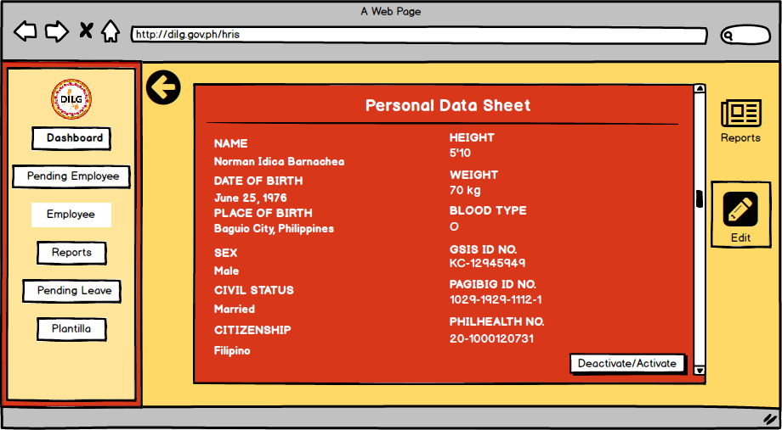

*Figure 35: Activate and Deactivate Employee Account*

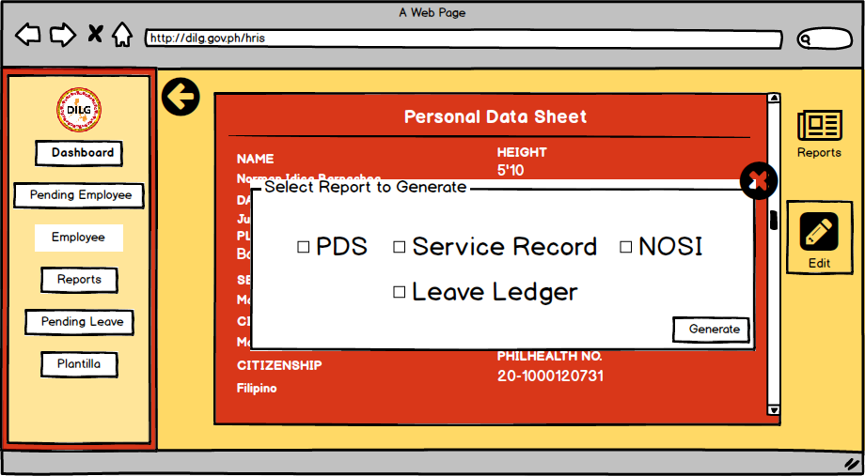

*Figure 36: Generate Report*

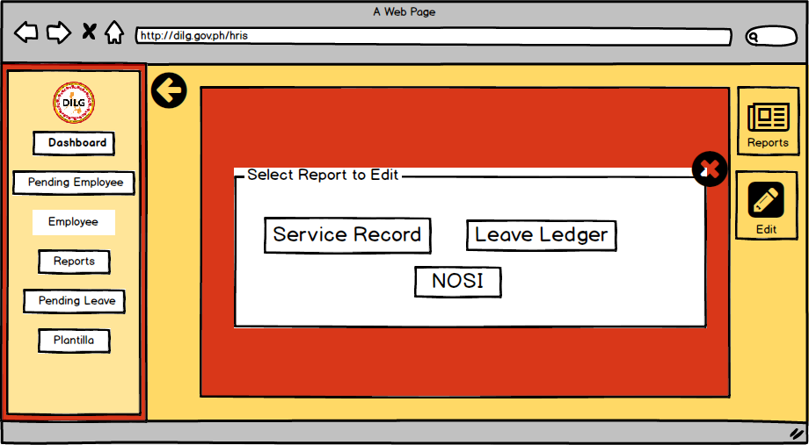

*Figure 37: Edit Report*

**

*Figure 38: Edit Report*

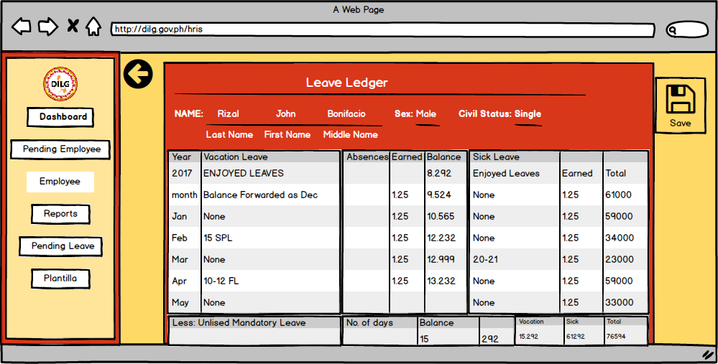

*Figure 39: Edit Leave ledger*

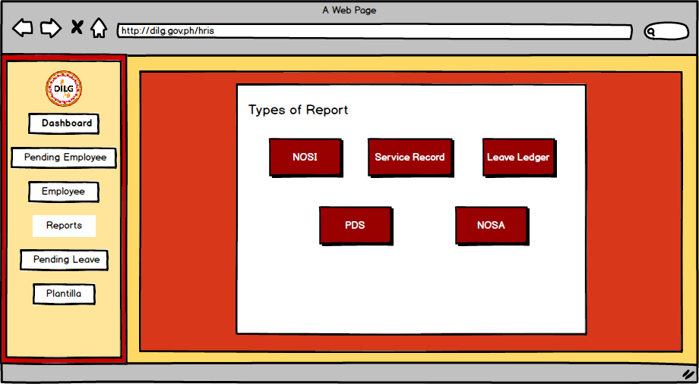

*Figure 40: Reports*

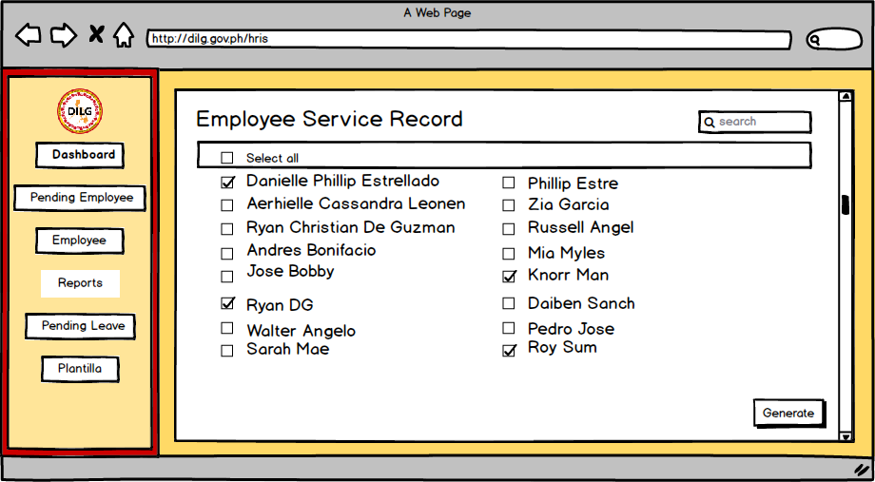

*Figure 41: Reports Service Record*

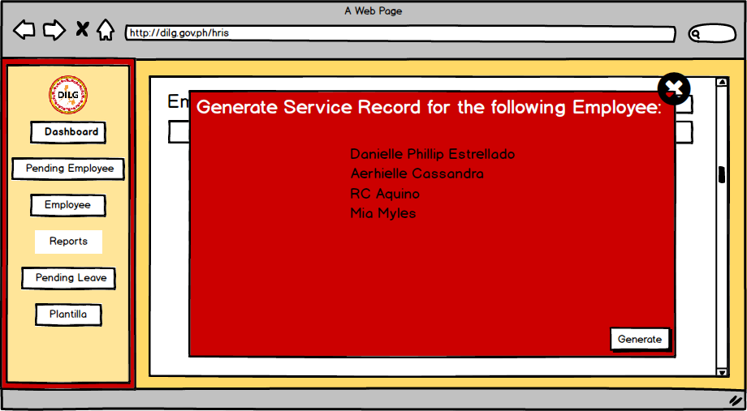

*Figure 42: Reports Service Record*

**

*Figure 43: Pending Leave*

**

*Figure 44: Application for Leave*

**

*Figure 45: Plantilla*

**

*Figure 46: Salary Grade*

**

*Figure 47: Previous Salary Grade*

**

*Figure 48: Add Salary Grade*

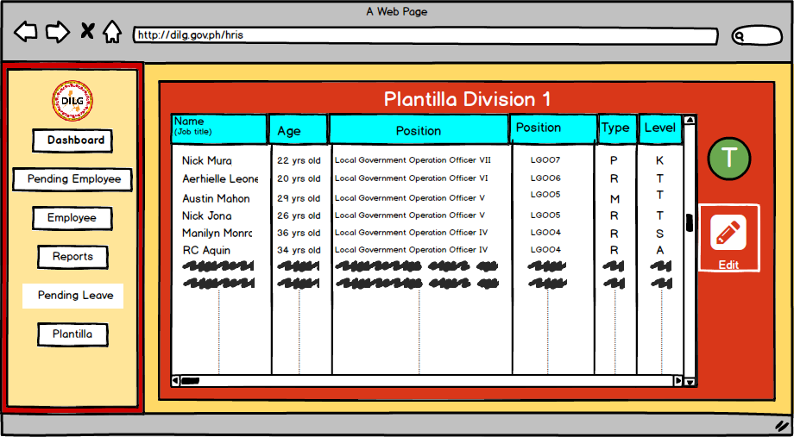

*Figure 49: Plantilla Division*

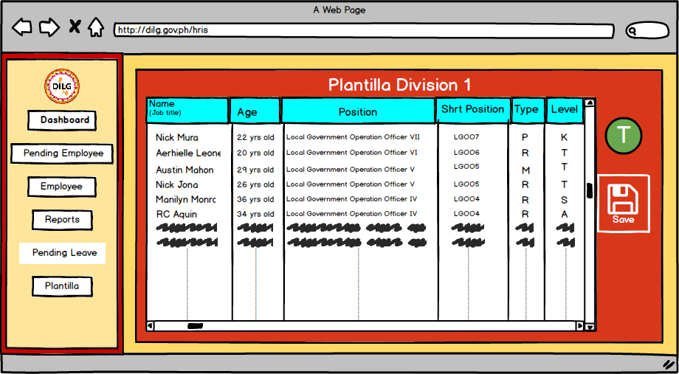

*Figure 50: Plantilla Edit*

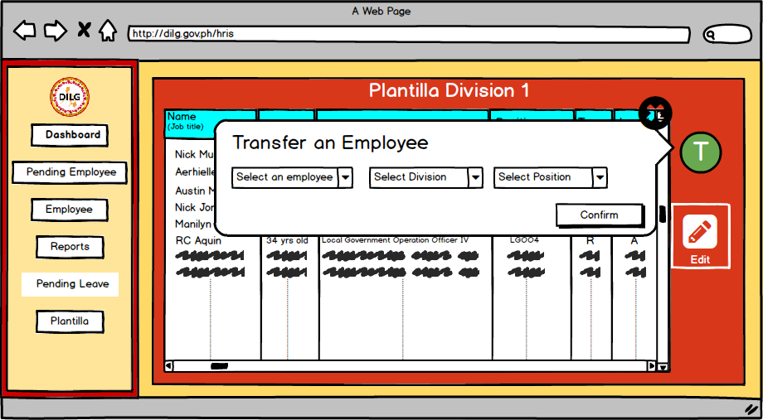

*Figure 51: Plantilla Promotion and Demotion*

**3.5.2 Employee**



*Figure 52: Reset Password*

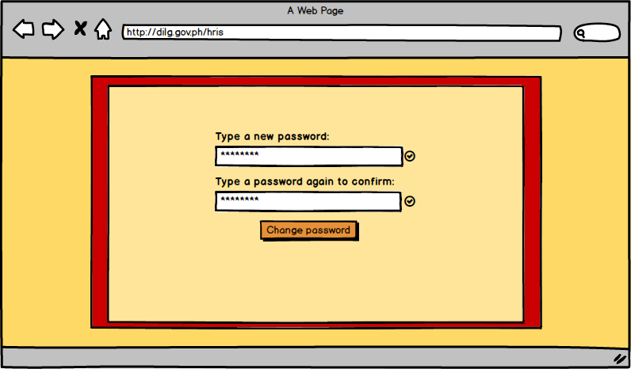

*Figure 53: New Password*



*Figure 54: Dashboard*



*Figure 55: Profile*

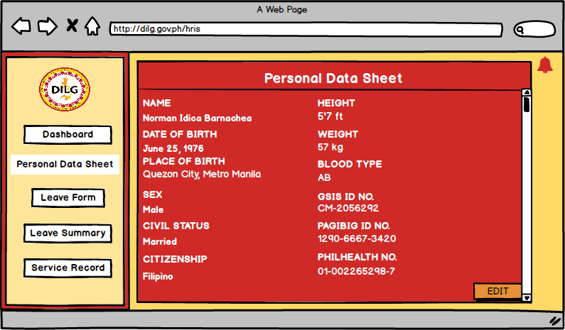

*Figure 56: Personal Data Sheet*

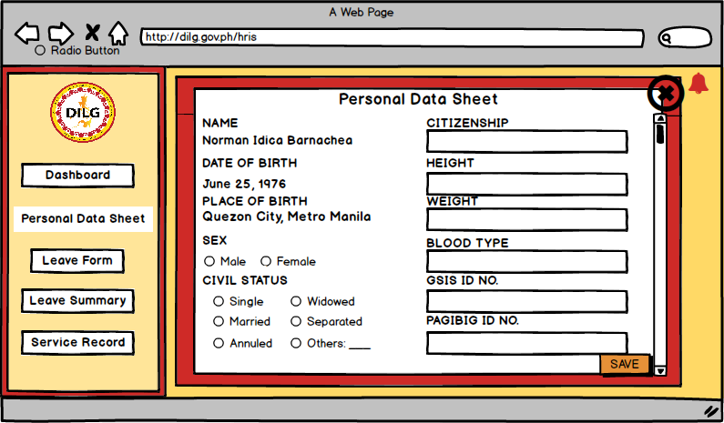

*Figure 57: Edit Personal Data Sheet*



*Figure 58: Application Leave Form*

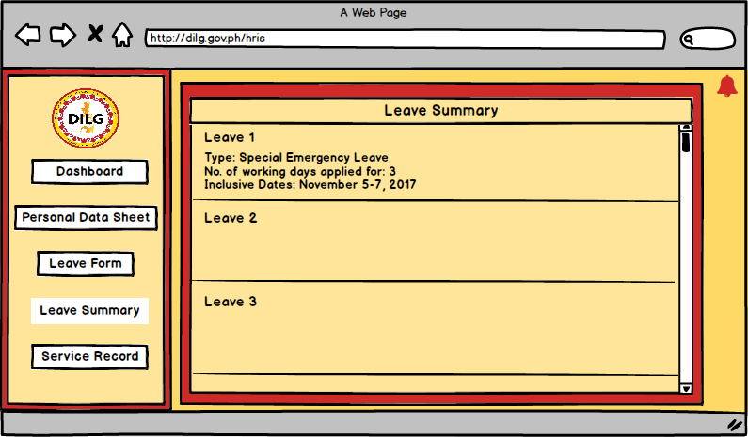

*Figure 59: Leave Summary*

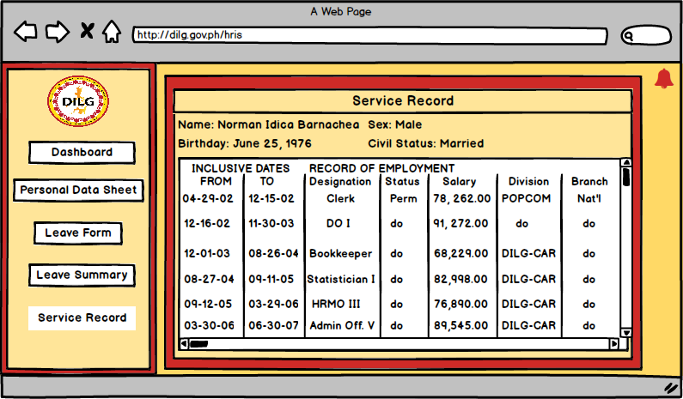

*Figure 60: Service Record*

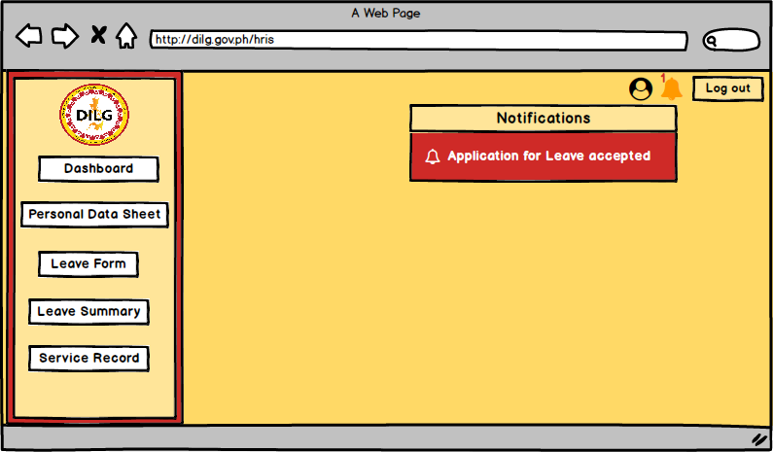

*Figure 61: Notification*

**3.5.3 Super User**



*Figure 62: Dashboard*

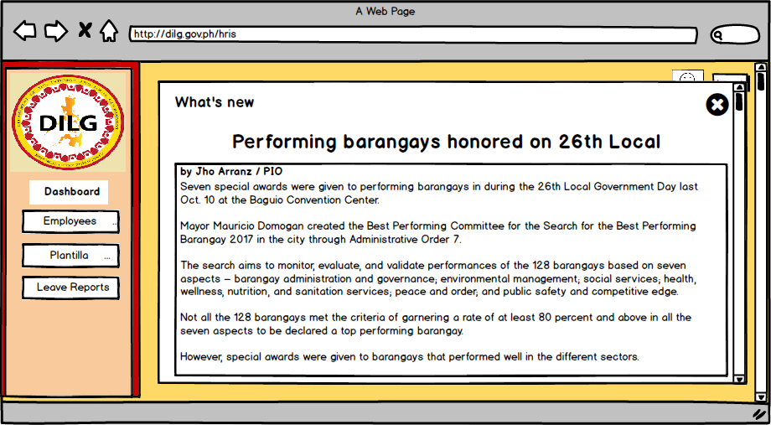

*Figure 63: Dashboard What’s New*



*Figure 64: Employees*

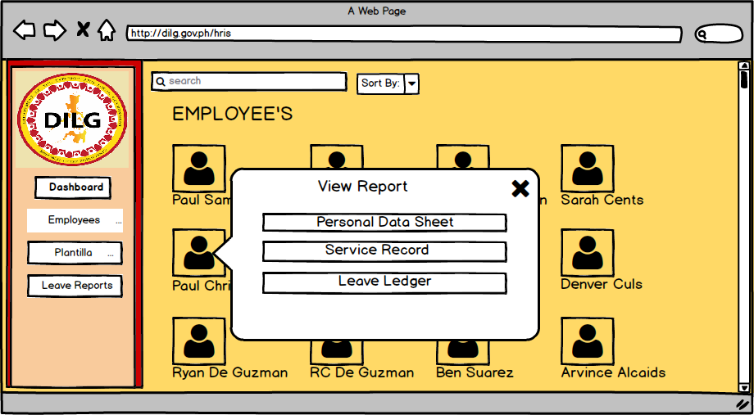

*Figure 65: View Employee Details*

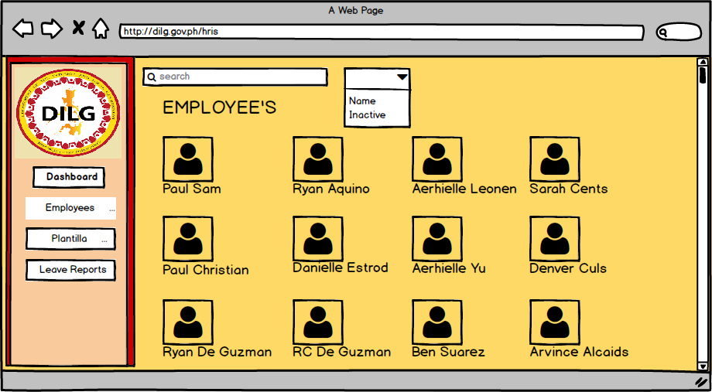

*Figure 66: Dropdown Option*

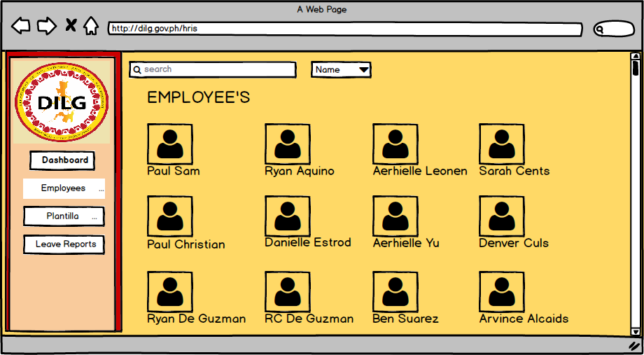

*Figure 67: Select Dropdown Name*

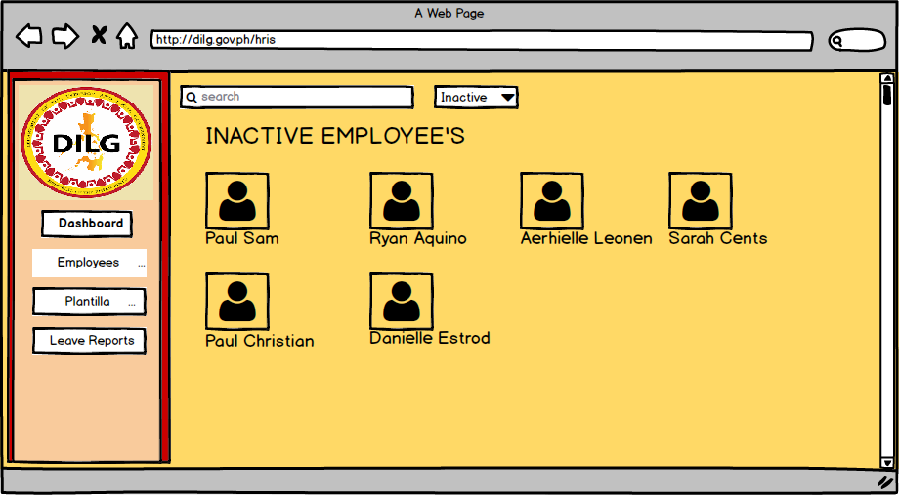

*Figure 68: Inactive Employees*

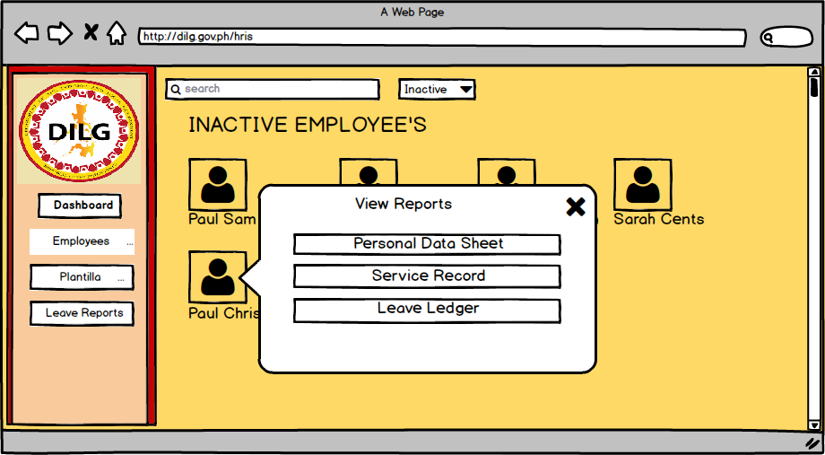

*Figure 69: Inactive Employee Details*



*Figure 70: Personal Data Sheet of Employees*



*Figure 71: Service Record of Employee*



*Figure 72: Plantilla*



*Figure 73: New Plantilla Setup*



*Figure 74: Leave Reports*



*Figure 75: View Leave Details*

**REFERENCES:**

[1] Human Resources Technology Council (U.S.) and United States Office of Personnel Management. (1997). *Governmentwide human resources information systems study*. Retrieved from

http://www.worldcat.org/title/governmentwide-human-resources-information-systems-study/oclc/38530163&referer=brief_results

[2] Michael J. Kavanagh and Richard D. Johnson. (2014, January 14). *Human Resource Information Systems: Basics, Applications, and Future Directions (4th. ed.)*. Retrieved from

https://books.google.com.ph/books?id=3TxbDgAAQBAJ&pg=PA1&source=gbs_toc_r&cad=2#v=onepage&q&f=false

[3] DILG. (2013). *DEPARTMENT OF INTERIOR AND LOCAL GOVERNMENT: Powers & Functions*. Retrieved from<http://www.dilg.gov.ph/page/Powers-Functions/21>

[4] ISO. *International Organization for Standardization 15489-1:2016: Information and documentation -- Records management -- Part 1: Concepts and principles*. Retrieved from <https://www.iso.org/standard/62542.html>

[5] Rouse, M., Gibilisco, S. (2015, January). *use case diagram (UML use case diagram)*. Retrieved from http://whatis.techtarget.com/definition/use-case-diagram

**APPENDICES**

**Appendix A:** Daily Time Record



**Appendix B:** Type of Leaves





**Appendix C:** Application for Leave Form



**Appendix D:** Computation of Leaves Credit





**Appendix E:** Service Record

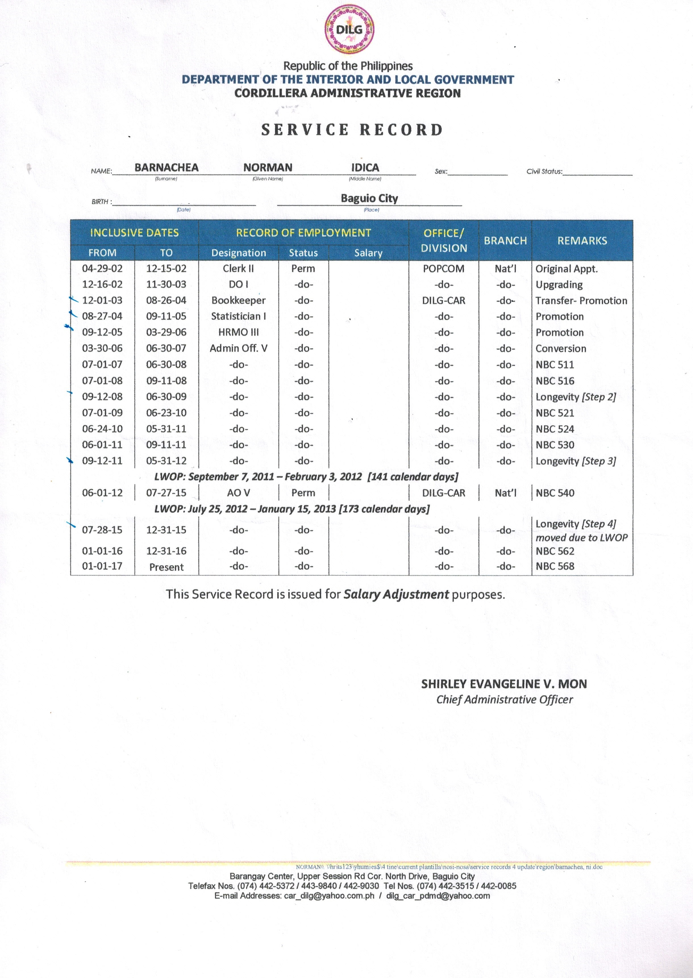

**Appendix F:** Notice of Step Increment

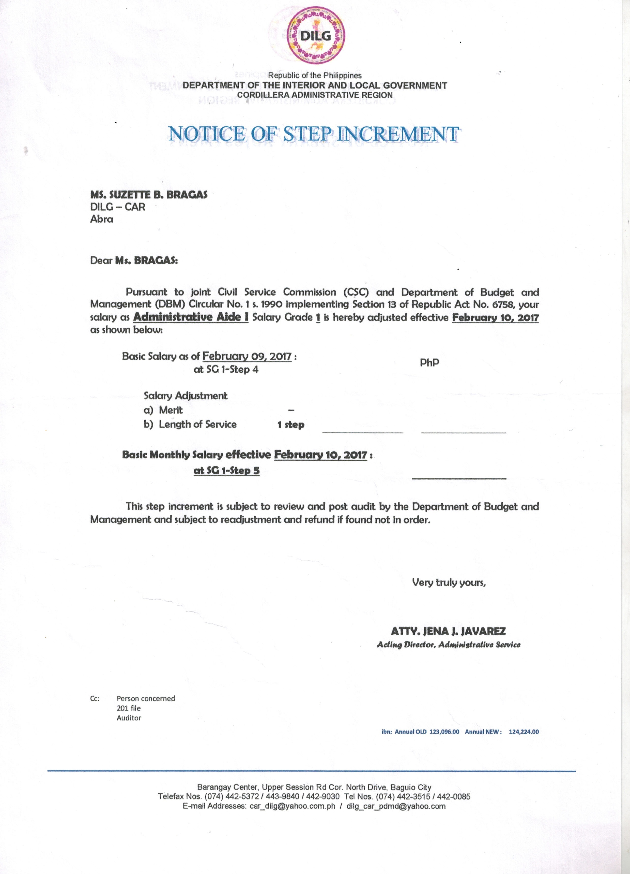

**Appendix G:** Notice of Salary Adjustment

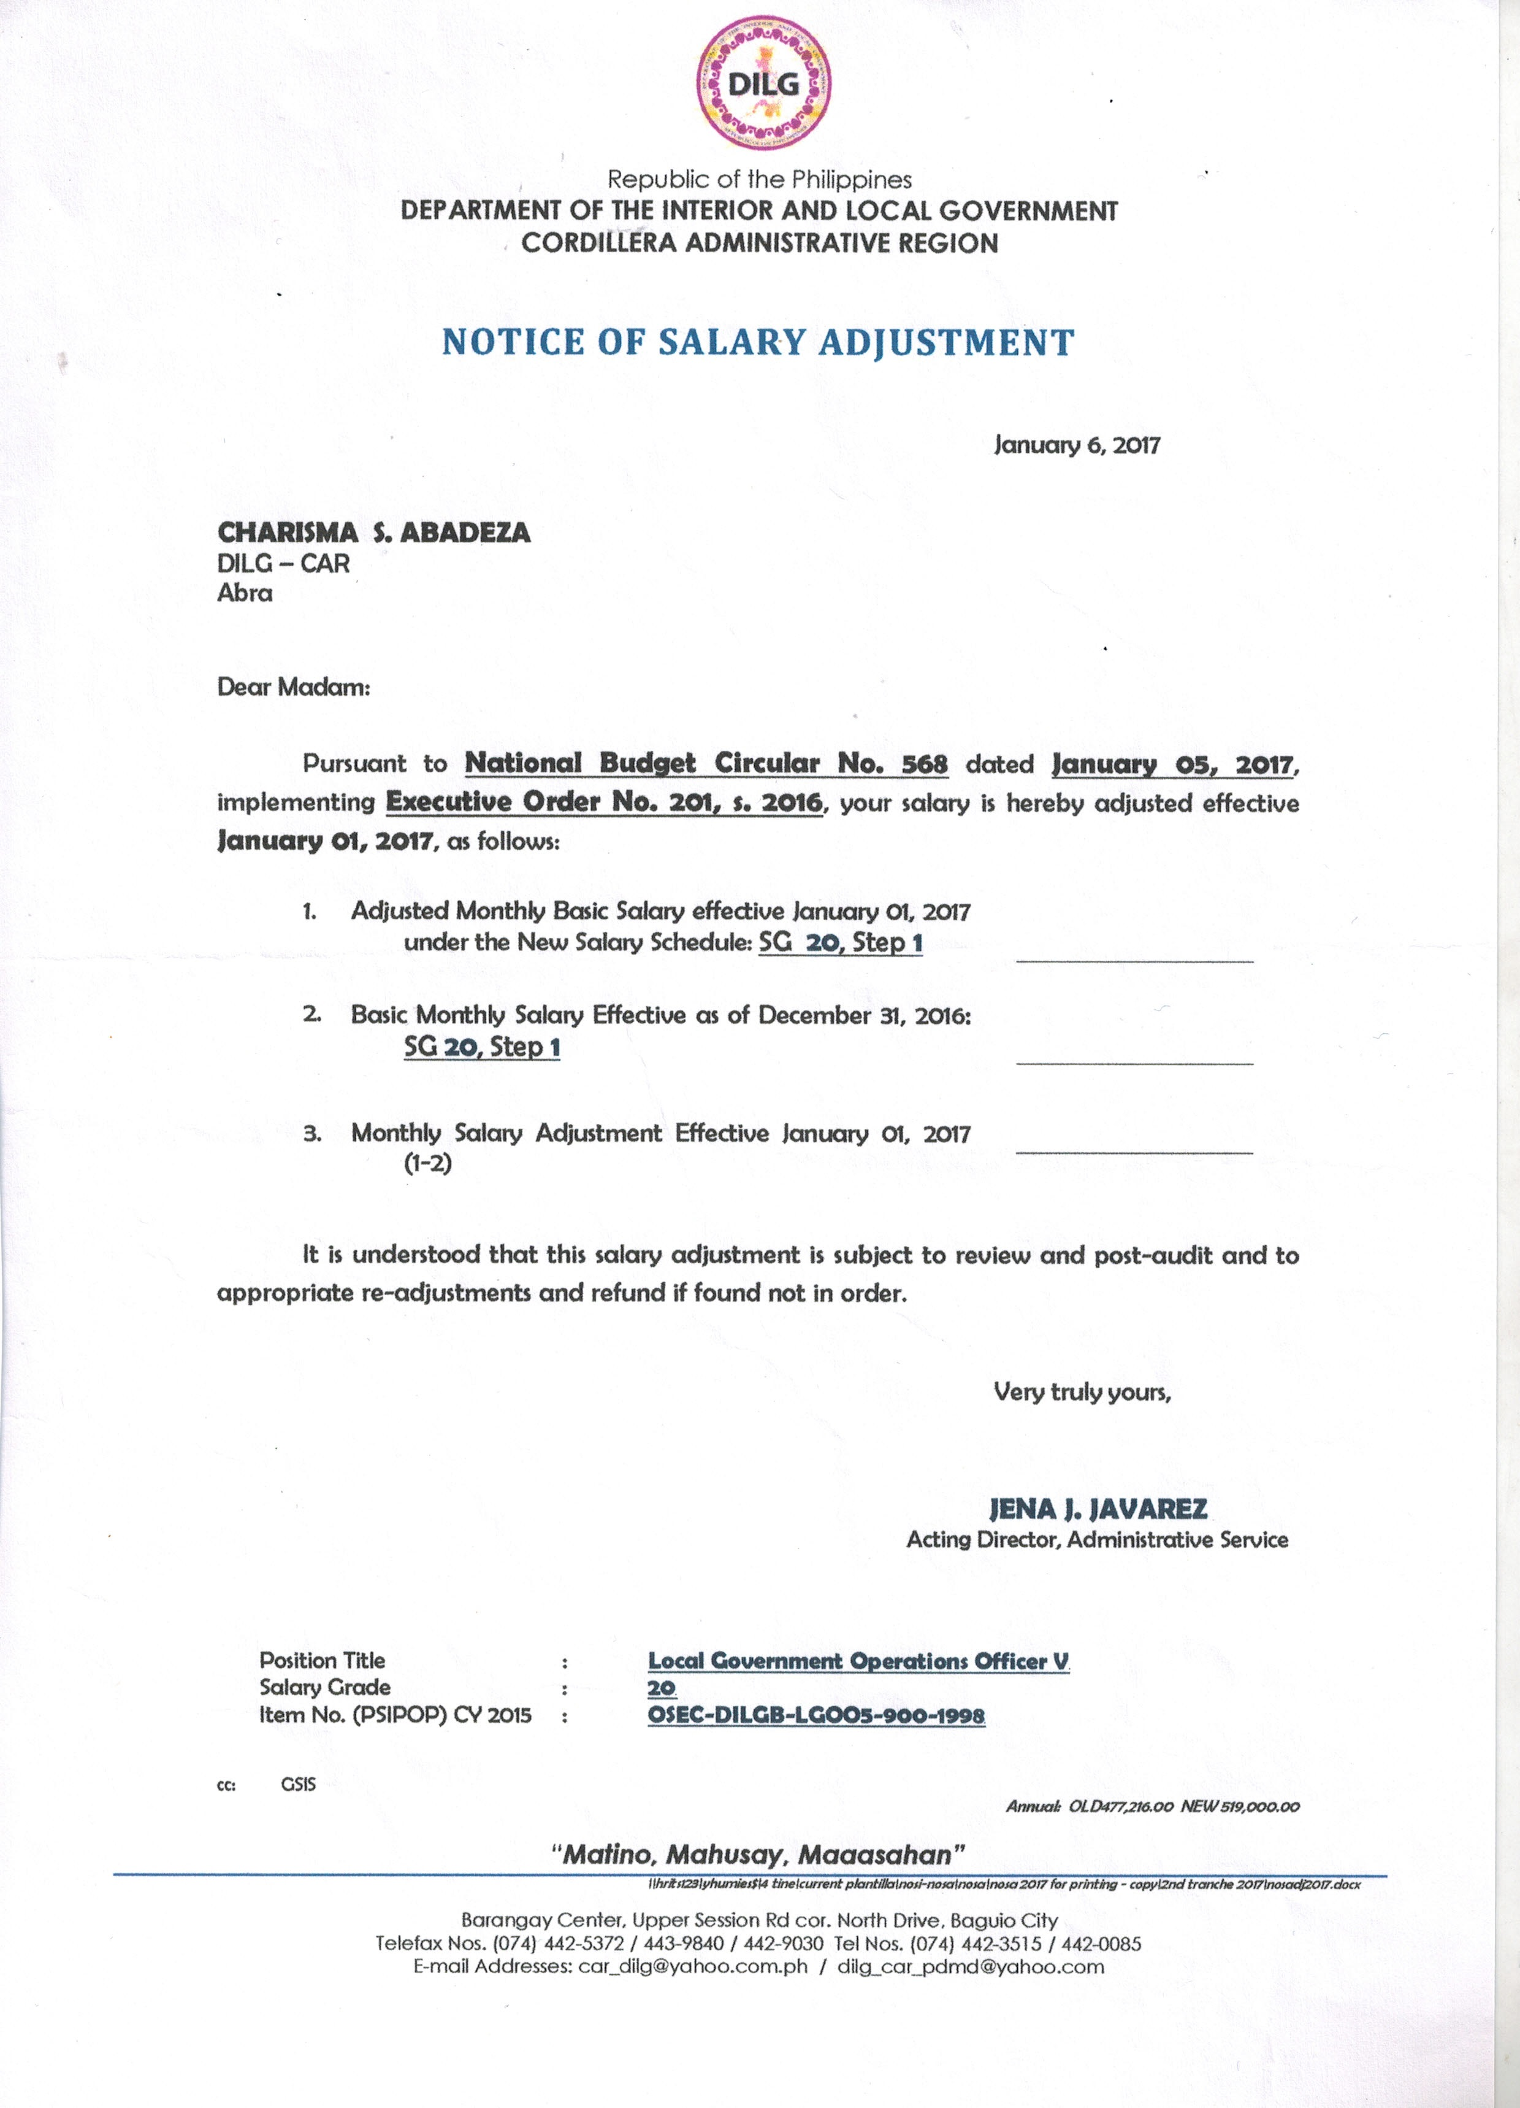

**Appendix H:** Leave Ledger Card

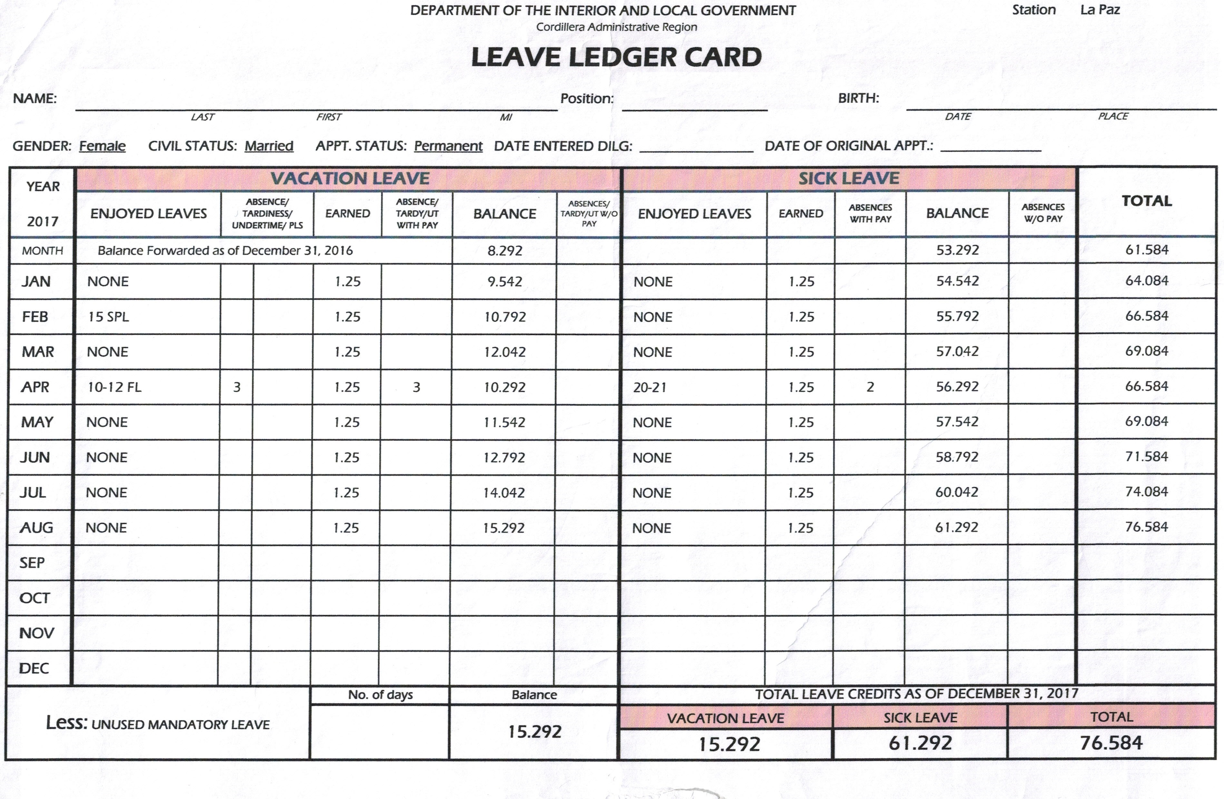

**Appendix I:** Personal Services Itemization and Plantilla of Personnel (Plantilla)



**Appendix J:** Personal Data Sheet







